# Phase 2 Project

# Become a back-end expert

**Learners Academy School Online Admin Management System**

version 1.0

Specification Document

----------------------------------------------------------------------------------------------------------------------------

**Document Version 1.0**

**Latest updated: 02- Dec–2020**

**Author: Shubham Kumar**

**Content**

**1. About this Document ………………………….............. 1**

**2. Introduction ……………………………………….............. 1**

**3. Flow chart …………………………............................... 2**

**4. Github link …………………………………………........... 3  
5. Solution Overview …….……………………………… 3**

**6. Steps to Pull the code ……………………………………. 4**

1. **About this Document**

**This functional and integration (FIS) document will enable you to understand the proposed solution of Learners Academy School Online Admin Management.**

**The content of the document will have a solution and its configuration details as it will be available for our client.**

1. **Introduction**

**This document describes the implementation of *Learners Academy* School Admin online management system and how its users can interact with the application.**

**Background:**

Learner’s Academy is a school that has an online management system. The system keeps track of its classes, subjects, students, and teachers. It has a back-office application with a single administrator login.

**Objectives**

The objective of this document is to describe how the solution of *Learners Academy* will integrate with Admin user to execute various roles.

This document also provides information on end to end workflow flow so that business users can understand the features and functionalities of the *Learners Academy School Online Management System*

The workflow mainly involves the following important aspects.

**The administrator can:**

● Set up a master list of all the subjects for all the classes.  
● Set up a master list of all the teachers  
● Set up a master list of all the classes – Class V to Class X  
● Assign classes for subjects from the master list  
● Assign teachers to a class for a subject (A teacher can be assigned to different classes for different subjects)  
● Get a master list of students (Each student must be assigned to a single class)

There will be an option to view a Class Report which will show all the information about the class, such as the list of students, subjects, and teachers  
       
The goal of the company is to deliver a high-end quality product as early as possible.

1. **Flow Chart**

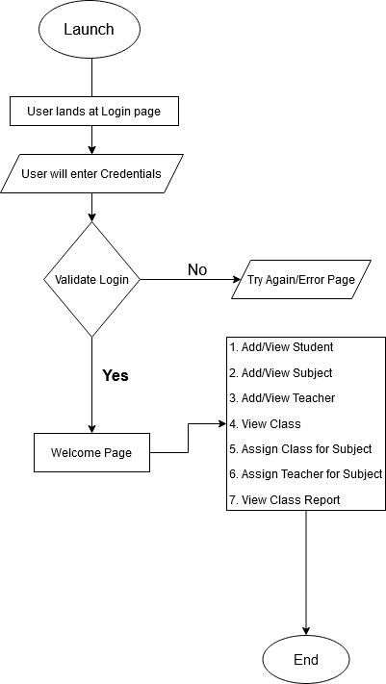

1. **Sprint planning**

**Learners Academy Admin Management System V1.0**

1. Project needs to be completed in 3 sprints: Approx. 21 working days
2. We are using Git Project Dashboard for tracking. Required Work Items are created in Git Projects

Work Distribution

Sprint 🡪 Start Date: 16th November,2020, End Date: 5th December,2020

Sprint 1: First week Completed the Basic functionality of the application.

Sprint 2: Second week completed the Database connectivity and final function of the application.

Sprint 3: Last week tested for Product Backlog, Change Request and Bug fixing on priority.

**5. Github link**

Source code of this applications has been pushed to GitHub. One can access that repository by clicking on below link:

[**https://github.com/sk112-cmd/**](https://github.com/sk112-cmd/)

**Steps to be followed to pull my remote repository to your system:**

1. Open git and create directory by using command mkdir name (where name indicates directory name)

2. Check its location and navigate to directory and open git bash at that location.

3. Create the empty git repository using command git init.

Now create pull request my using command git pull

https://github.com/sk112-cmd/Project1.git

4. Check the contents in directory

5. Use command “git add .“ to add files and command git commit –m “Type your message” to commit changes.

You can push to remote repositories using following commands

1. git init

2. git remote add origin “your repository URL”

3. git add .

4. git commit –m “Type your message”

5. git push origin master

**6. Solution Overview**

**Platform requirement**

The platform used for this project is eclipse IDE, Tomcat, XAMPP- PHPMyAdmin: MySQL database, Firefox/IE/Chrome Browser, Notepad++ or Sublime Text